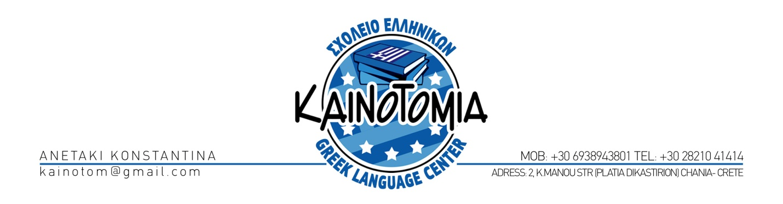
PRICE LIST 2013
INTENSIVE COURSE 2 WEEKS (20 HOURS/WEEK) 550,00 euro
INTENSIVE COURSE 3 WEEKS (20 HOURS/WEEK) 700,00 euro
INTENSIVE COURSE 4 WEEKS (20 HOURS/WEEK) 900,00 euro

* COURSE OF 1 WEEK “I WANT TO SPEAK GREEK”(10HOURS) 200,00 euro
( special program of intensive oral practising)
INTENSIVE COURSE OF 3 MONTHS (15 HOURS/WEEK) 2.500,00 euro
COURSE ONE- TO- ONE 1 HOUR 30.00 euro
5 HOURS 150.00 euro
10 HOURS 260.00 euro
15 HOURS 410.00 euro
20 HOURS 560.00 euro
*COURSE OF PREPARATION FOR THE GREEK CERTIFICATION
*COURSE OF BUSINESS GREEK
*COURSE OF ANCIENT GREEK
* After request

: IN ALL PROGRAMS INCLUDES FOR FREE:
✓ Information pack for school and the sightseeings of the area that you visit
✓ books and educational material
✓ Dinner in a Traditional tavern
✓ tour to the city's museums
✓ greek film
✓ 1 hour of traditional Cretan dances
✓ 1 hour Greek cookery lessons
✓ 1 hour presentation of the Cretan Diet
Free internet access

AFTER CHARGE:
* EXCURSION TO THE GORGE OF SAMARIA
* EXCURSION TO ELAFONISI
* EXCURSION TO KNOSSOS
*EXCURSION TO GRAMVOUSSA ISLAND
* EXCURSION TO MOUNTAIN VILLAGES OF CHANIA

ASK US FOR THE EXCURSIONS PROGRAM OF RHODES ISLAND, THESSALONIKI, PIRAEUS

ACCOMMODATION (1 PERSON)
HOTEL
C! CLASS ROOM WITH BREAKFAST: 50.00 EUR
B! CLASS ROOM WITH BREAKFAST: 75.00 EUR
Apartment 60,00 EUR
HOST FAMILY 45.00 EUR
ABOVE RATES EXIST FOR THE WHOLE YEAR

OTHER SERVICES:
TRANSFER IN ARRIVAL AND DEPARTURE FROM THE AIRPORT 100,00 euro

STARTING DATES 2013:
JANUARY 7TH FEBRUARY 4TH
MARCH 4TH APRIL 1ST
MAY 7TH JUNE 3RD
JULY 1ST AUGUST 5TH
SEPTEMBER 2ND OCTOBER 7TH
NOVEMBER 4TH DECEMBER 2ND

HOLIDAYS IN WHICH WILL NOT BE MADE COURSES:
1/01-06/01, 18/03, 25/03,
1/05 -6/05, 24/06, 15/08,
28/10, 21/12-30/12

REMARQUES:
THE RESERVATIONS FOR COURSES AND OTHER SERVICES FOR OUR SCHOOLS ARE MADE ONLY BY THE SCHOOL OF CHANIA
1 TEACHING HOUR IS 50 MINUTES
IN CASE THAT THE STUDENT IS ALONE IN THE COURSE THE HOURS ARE REDUCED BY 50%
A CANCELLATION OF A PROGRAM 5 DAYS BEFORE NOT INCUR A CHARGE.

